**Predictive Modeling with Alteryx**

**by Qi Sun**

**Here is a screenshot of the workflow for Numerical Prediction:**

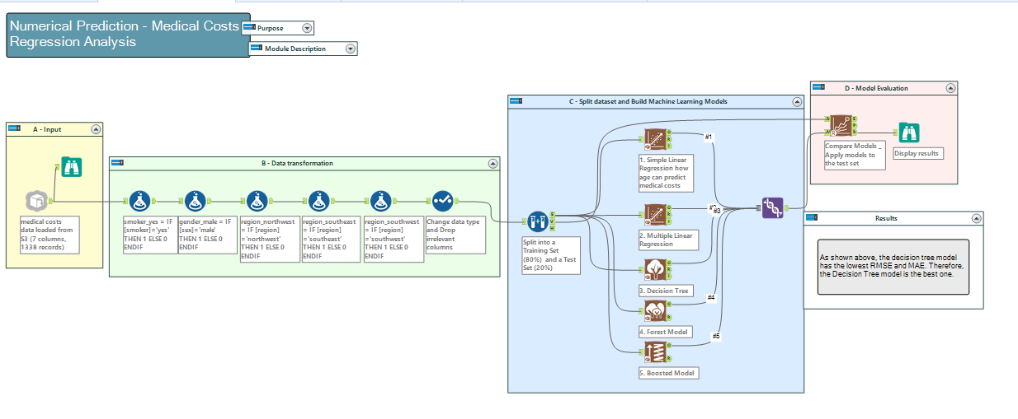

**Here is a screenshot of the workflow for Yes/No Prediction:**

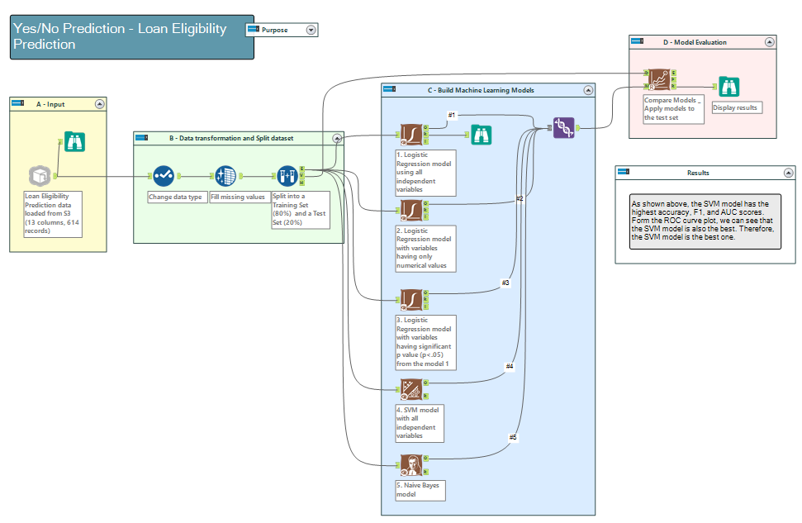

**Screenshot of the results from the Numerical Prediction:**

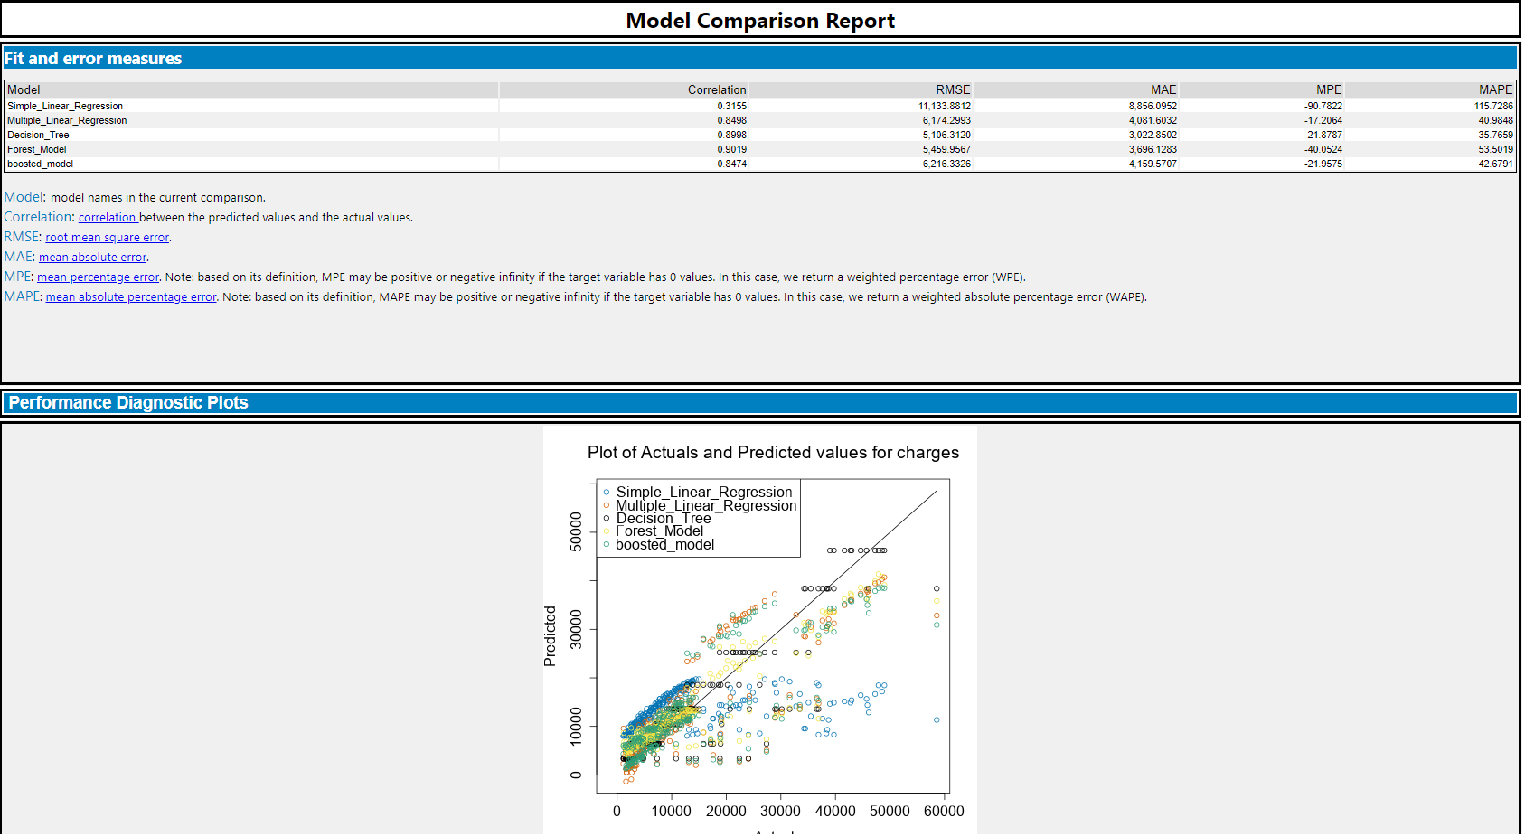

**Screenshot of the results from the Yes/No Prediction:**

